# Honeypot Install Documentation

Code can be found here https://github.com/lachlanmaclean/honeypot_loggerThe Honeypot Installer is built using PowerShell 5.1 and packaged using Windows IExpress.

Below are the settings I used to package the PowerShell script.

IExpress build configuration  
**Must Run as Administrator to create EXEs**  
Package Purpose: Extract files and run an installation command  
Title: Honeypot Installer  
Confirmation Prompt: No Prompt  
License Agreement: Do not display a license  
Packaged Files: .\email_login.ps1  
Install Program to Launch: powershell.exe -ExecutionPolicy Bypass -File email_login.ps1  
Post Install Command: None  
Show Window: Default  
Finished Message: No Message  
Package Name and Options Path: “<Absolute file path to email_login.ps1>\Honeypot Installer.exe”  
Package Name and Options options:   
Hide File Extracting Process: TRUE  
Store files using Long File Name: TRUE  
Configure Restart: No restart  
Save Self Extraction to same folder as powershell script

Honeypot Installer creates a new powershell file in C:/Secure23. It will create this directory if it doesn’t exist. This is the powershell that contains the email functionality, this is what gets trigger on Logon.

Honeypot Installer then creates a Scheduled Task on Logon.

## Created Scheduled Task

The Task Scheduled event is called **LogAgent** and can be accessed by opening Task Scheduler (**taskschd.msc**)

Task Scheduler (Local) / Task Scheduler Library / LogAgent

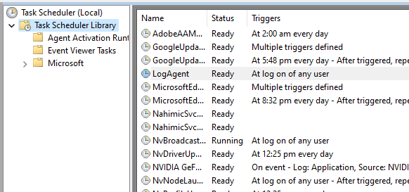

## To Uninstall

Delete the **LogAgent** Scheduled Task

Delete c:/Secure23/**send_email.ps1**

## To Do

Uninstall Command  
Edit vendor and customer details  
Check if the Task is installed already